West Hull Ladies
RRC

April Newsletter

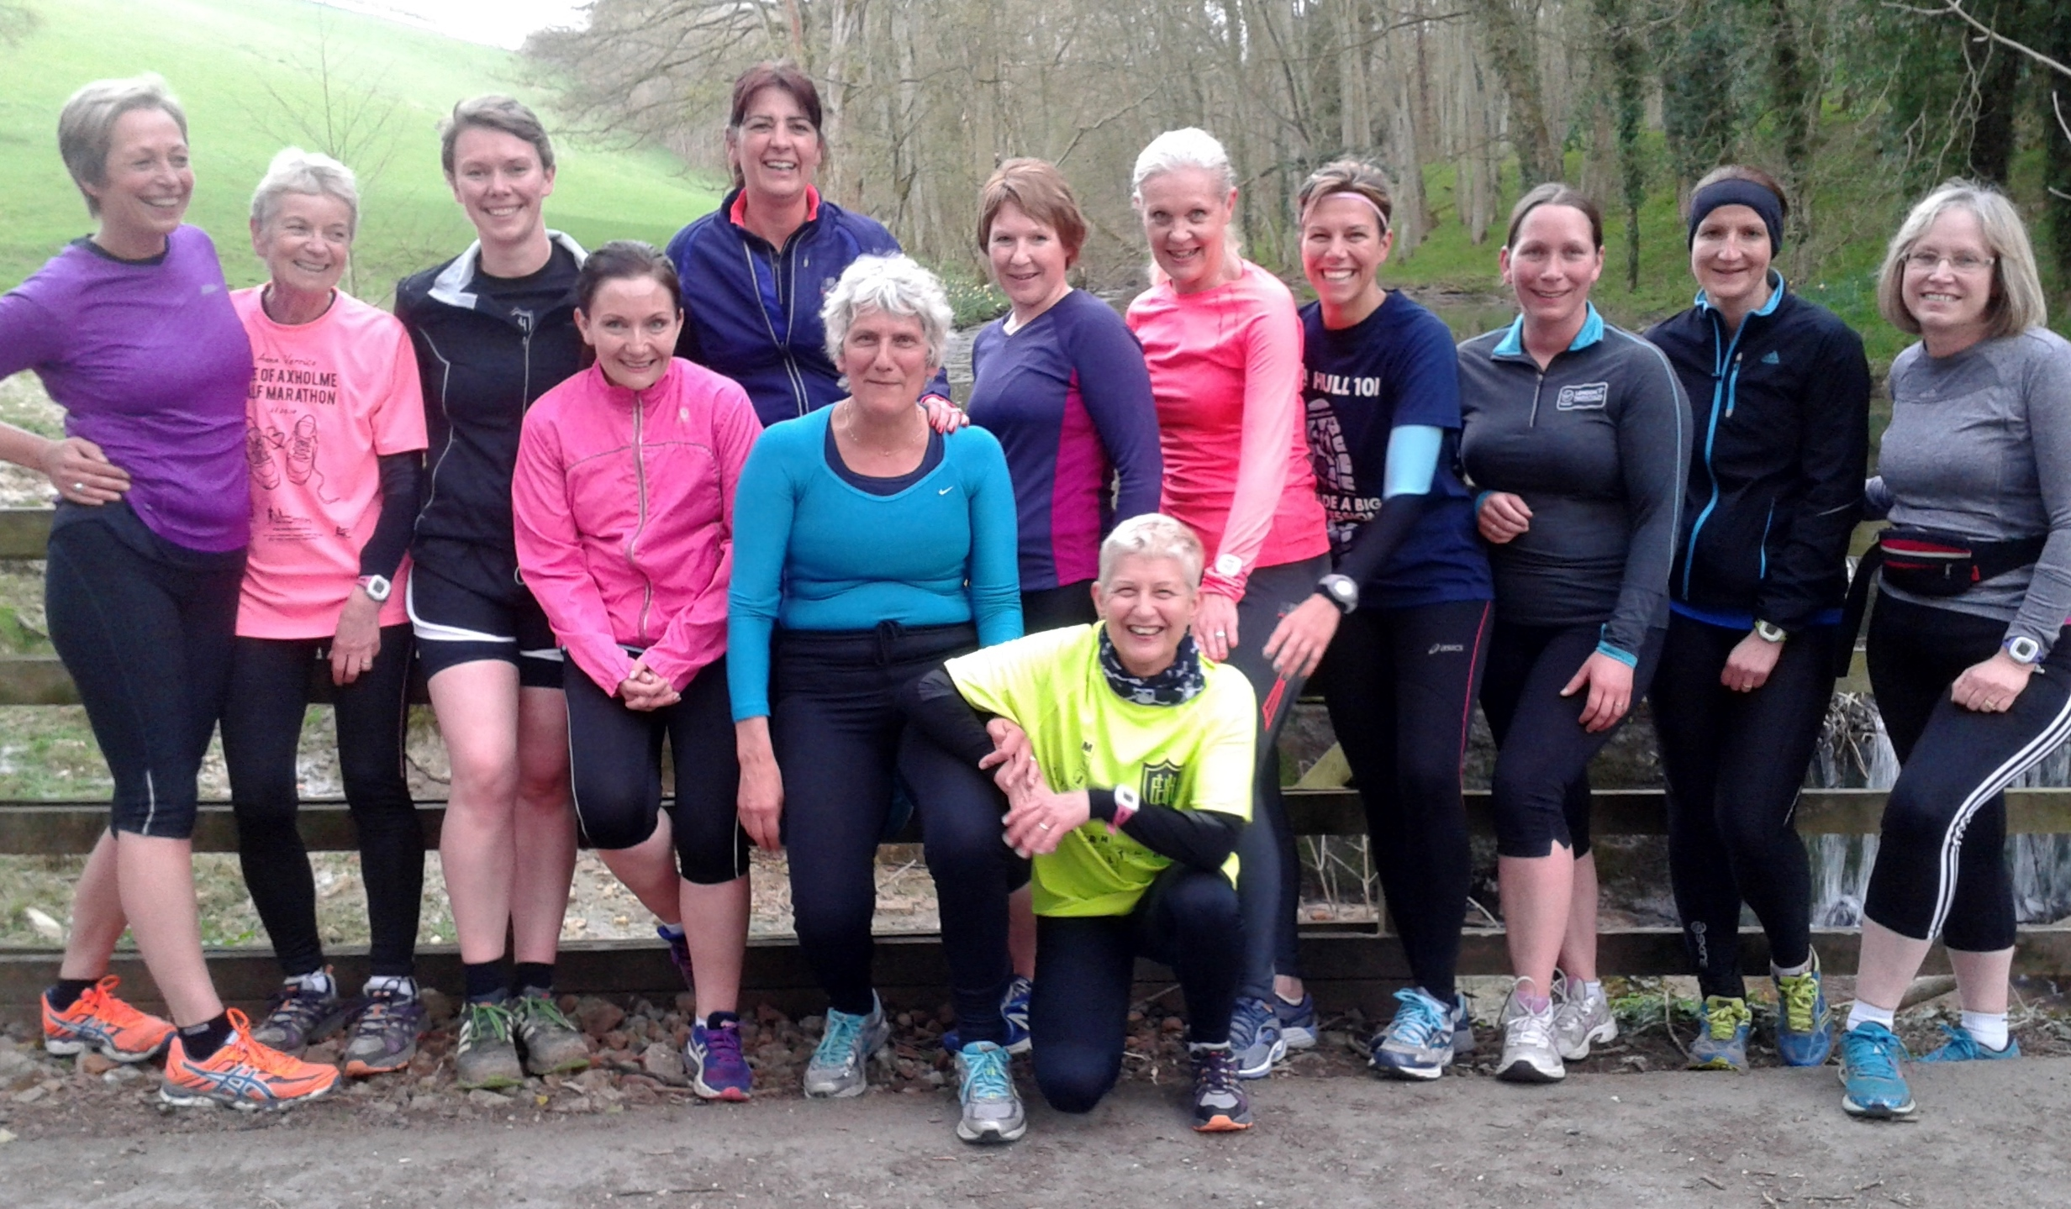

April away night at Drewton Estate

Away night- Drewton Estate

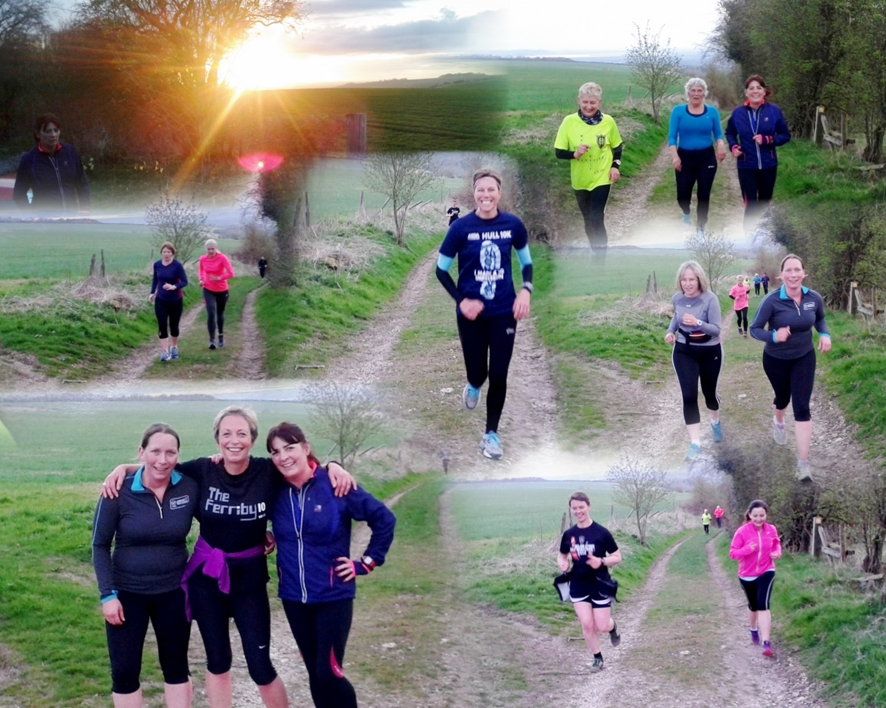

West Hull Ladies

WEST HULL LADIES RRC COMMITTEE MEETING

Committee Meeting 13th April 2015

Minutes

Present - Jill, Zoe, Anna, Liz, Jan, Amanda, Linda, Sandra

- Apologies from Annette, Karen, Rachael, Maria
- Minutes from 2.2.15 accepted as true record
- All actions had been completed - Sandra had sent out email re committee posts. Jill had in relation to awards for the Presentation Evening and Andrea had in explaining the parkrun to the 0-5k ladies.
- Amanda updated on the Hull Marathon - we had enough volunteers for the water station at West Park but did not have the experience or spare capacity to organise a fun run. It had been suggested by Amanda that the larger Clubs could maybe do this and we would support in whatever way we could. It was impossible to say at the present time due to insufficient details.
- A prospective member of the Club has questioned the training start times as they were too early for her having young children. An email had been sent out to all Club Members - only 4 had replied and they were happy with our start times. Sandra asked if the start time on the Monday of Committee Meetings could be changed from 6.15pm to 6pm allowing a full training session to be completed. This was agreed and ladies would be reminded of it when the Agenda for the meeting was circulated.
- Sandra updated the Committee about the GB Relay saying that quite a few ladies had said they wanted to be involved. T-shirts for the event could also be purchased for £12. We pick the baton up from Barton on the 1st July at 3.37pm and run to Hessle Road nr Asda. Agreed that details would be put into the Newsletter - ACTION Sandra to forward details to Newsletter Editor.
- The organisers of North Lincs Half Marathon had invited Clubs to place Club Banners in the finish area. ACTION Jill to take the banner to organiser’s home address. Also discussed purchasing a second Club banner stand - Action Liz to source and obtain costing.
- AOB Amanda updated the Committee of the fact that Anna had taken over the newsletter from Hayley. Members thanked Hayley for the excellent newsletters she had produced and wished Anna success in her new role. Amanda also queried whether the training emails should continue with feedback or whether that should left to Facebook. Overwhelming majority for the emails to be sent out, as then there was also a permanent record.

Meet a member : Andrea Thomson

Age 45 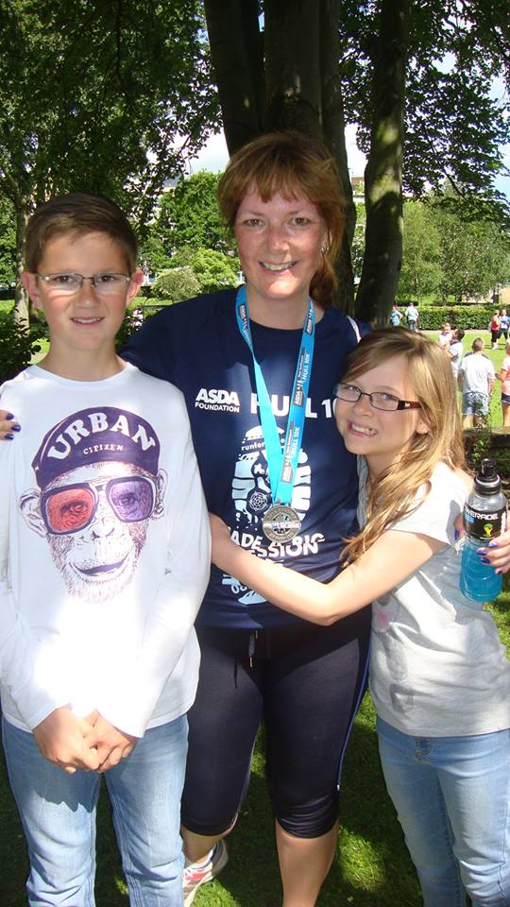

Member of WHL since – August 2013

What do you do when you’re not running? – ( work/hobbies/family)

I work part time for Hull City Council in the Insurance team. I’ve been married to Phil for 15 years and we have 2 children Daniel (13) and Holly (11) and a rescue dog called Buster. When I’m not ferrying the children around to football, dance class, choir and netball matches I like visiting the theatre and live music. I like baking, but unfortunately I end up eating most of it.

How long have you been running? - Intermittently since around 2006 but only really consistently since I joined West Hull Ladies in 2013

Why did you start running? - See the last of my hobbies! Initially it was to lose weight. When that didn’t work it was so I could eat cakes and not feel guilty

Favourite distance – At the moment 5k - particularly parkrun but that might change

Favourite bit of running kit - I got a Garmin for Christmas. It’s really helped me have an idea of my pace and to see any progress.

Any injuries? - Not through running, however about a year after starting I slipped a disc in my back which I didn’t get fully sorted for about 18 months. This stopped me running and I struggled to get back into it afterwards. More recently 2 broken toes – sheer clumsiness!

Running goals? – Loads! Sub 30 minute 5k, sub 60 minute 10k and to run a marathon one day.

Proudest moment running related or otherwise – probably completing the 24 mile off road Rudolph Romp in December 2014, but I also was really excited when I got a parkrun pb the other week after about a year and a half.

Best piece of advice you’ve received – you’re beating everyone else who’s still sitting on the couch.

Running alone or with friends? – before joining WHL I always ran alone, but since joining I prefer to run with friends particularly longer distances. Now and again though it’s nice to run on my own with my ipod on.

What keeps you motivated? – I like cake, chocolate and wine! I’m really proud to be a part of this fantastic supportive, inspiring club, knowing that I am getting fitter and improving no matter how small an improvement it is and setting a positive example for my kids.

Meet a member : Anna Shepherdson
Age 40 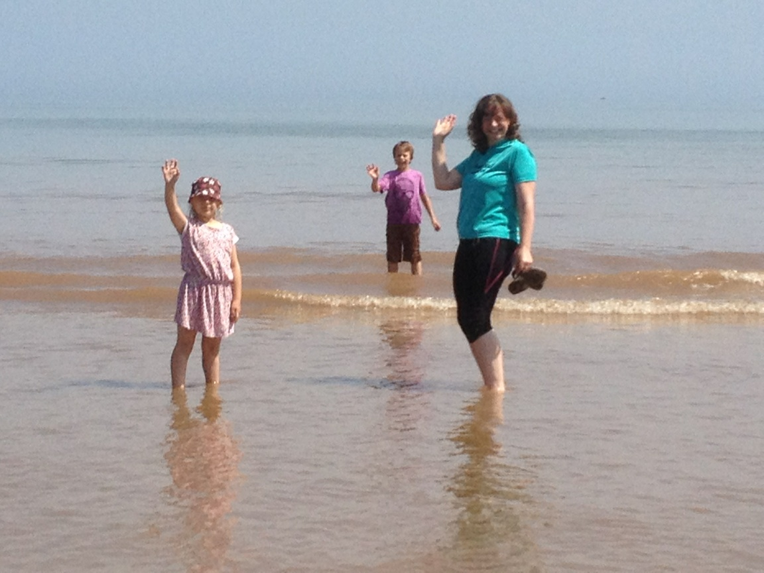

Member of WHL since – 2012 I think

What do you do when you’re not running? – ( work/hobbies/family)
I teach part time at a secondary school in Hull, teaching art and design.
I am also a personal taxi service/ agony aunt/ private tutor/ chef/ cleaning lady/ seamstress etc at home!
For non running fun, I would chose sewing/ drawing/ going to the beach/ going out with friends.
How long have you been running? - I put my name forward for Hull's Race for Life back in 2001, and to get ready for it I did my own version of 0 – 5k by adding laps around Pearson park. (did it in 27 minutes- which I would LOVE to do now!!)
I had a little children shaped break from 2003 to 2006, then started again just so that I could listen to music that wasn't the Thomas the Tank theme tune over and over! I only added distances more than 5 k when I joined the club.

Why did you start running? - I am not sure really. I have always liked keeping vaguely fit- going to swimming and aerobics classes since leaving PE lessons at school. However, running appealed to me because its outside, free, available any time, you can travel/ get places, don't need much kit. I suppose I just dared myself to try it.
I would now add that I think it’s a sociable sport, and I am very glad that I did join as the community of running- club/ park run etc is so friendly and supportive.

Favourite distance – I love a ten K. Its a manageable and comfortable distance for me, but gets me to push myself a bit. And there are so many fab ten k's to chose from round us.
Favourite bit of running kit - I am a sucker for a new pair of trainers. I would wear trainers for work if I could- quite jealous of the PE staff!
Any injuries? - Yes- one dodgy knee- which needs a bit of a stretch out over longer distances. I discovered this by helping a woman push her car whilst near the end of a long run. It was the perfect angle for a good calf stretch and I managed the last bit of the run pain free!

Running goals? – I don't really set targets or times- they scare me a bit. However, I would like one day to stretch to a half marathon. I am getting there with the ten mile distance, and it would be great to extend this a bit further. And when I am able to get out on Saturdays again- volunteering at park run is an important goal for me too.
Proudest moment running related or otherwise – I measure the success of a run on how comfortable it felt. So my proudest feelings are getting home after a satisfying run where I feel I have pushed myself a little but really enjoyed being out.
One proud moment was when a friend of mine asked me to help her train for and run the Jane Tomlinson last year- I felt flattered to be asked for running advice- to be thought of as “a runner”!

Best piece of advice you’ve received – Stretching. Very important.
Running alone or with friends? – As an airhead/ daydreamer, I have always enjoyed quite solitary sports- so am happy running on my own. However- the club offers other opportunities- such as off roaders, longer runs, speed work- all of which I would never do on my own. And the company is always fab which helps the miles to fly by!
What keeps you motivated? – Those endorphins! Nothing like the warm buzzy feeling after a satisfying run!

Race Report: Bridlington 5 : Sarah C

I was very nervous as this was my first proper race – apart from the Park runs. Thankfully the toilets were just down the road!
We set off at the back of the pack and that’s were we stayed (my husband ran with me for support). It was cold and windy on the cliff top but a great first run – it had ups and downs and steps as well. Liz H was in the distance and I focused on trying to keep her in view, I found I struggled after some of the inclines but hopefully I’ll get better with experience. One lady overtook me at about the 4 mile mark and I followed her until I could see the finish line and then I put a sprint on and overtook her! My chip time was 59:54 so I was pleased that I managed to do it under an hour. The malteser bunny at the end was worth it and the medal is on display at home. Feeling proud!

Race Report: Brighton : Rachel A

When I joined WHL in July 2014 I clearly remember saying, on my very first night, that 'I'd quite like to do a half marathon, but never the full 26.2'. Fast forward to the excitement of the London ballot results and with some encouragement from Karen (yes - it's ALL her fault) I found myself clicking the button to enter Brighton marathon in April 2015.

I started my training plan in December with both fear & excitement in equal measure. With the support and encouragement of WHL I slowly ticked off the runs, did a couple of half marathons, and started to build up the mileage. I did all my long runs on my own, just me and my audio book. I knew I would be running Brighton alone so felt the need to mentally prepare for that. The training went well, seemingly too well. A few weeks to go and I was hit a niggling injury to my left hip/pelvis that I couldn’t shake off. The less I ran the more it hurt and I seriously began to wonder if I'd make it to the start line. I have to thank Karen for her daily texts of encouragement at this point; they kept me sane. Even as I picked up my race pack, my hip was still niggling and I also had some twinges in my left knee. I was scared!!

Race day arrived and we blindly followed the crowds in the direction of Preston Park. Spectators had to leave the park before the race start, so I bid farewell to my husband and joined the toilet queue. The race was about to start and the queue wasn't any smaller. Spotting an empty block of urinals, myself and about 6 other ladies decided to take decisive action. We each held the door closed for the lady in front and then used our best yoga moves to make use of the facilities. We then legged it to our starting pens just in time!

The first few miles were around the park and the city centre. It was crowded & there were pinch points where I was almost slowed to a walk. I found these miles really frustrating. In hindsight, it was probably a good thing; it gave my hip a chance to warm up. Once we got onto the seafront the crowds of runners thinned and we headed out along the coast on a long out & back. The sun was out and it was HOT! I knew my liberal application of sunscreen had been a wise move. I found a comfortable pace, my hip wasn't hurting, and I felt strong.
As we headed back into the city centre, around mile 11, I felt my knee twinge. When I saw my husband at halfway (armed with my electrolyte drink) I still felt relatively good. But, a couple of miles later, as I headed into Hove, my knee really started to hurt and by mile 18 my pace had slowed.

The crowds to this point had been amazing. Every step of the way there had been someone offering encouragement.
I lost count of the times I heard 'Go West Hull' or 'Go Rachel'. It was an electric atmosphere. But, I knew that my biggest challenge was still ahead. I had heard about miles 19-23, an out and back to a power station that some race reviews describe as soul-destroying. However, there were marshals everywhere, a steel band, and even some teenagers on bikes who'd ridden up to cheer us on. It certainly wasn’t lonely, but it was hard! I was counting down the miles now & my hip/pelvis was starting to ache. At mile 23 they were playing messages of support that had been filmed by family/friends at the expo. It was designed to help you 'Find your Strong'. All it made me do was cry! At this point I thought that the experience had been amazing, but once was enough!

The final three miles were a bit of a blur. We headed back out onto the seafront in the full midday sun. We ran along the promenade among beach huts, with the sea glistening on our right, and huge crowds screaming support. By now I was in a lot of pain and had to dig deep. 'West Hull Ladies are strong' I told myself time and time again. 'Pain is temporary, pride is forever' was my other mantra. When I saw the finish line I started to think that maybe I would run another marathon in a couple of years; I was already forgetting the pain! By the time I'd collected my goodie bag and met my husband in the beach village I could barely bend my left knee. Despite the pain I chattered away about which marathon I would run next year. He just smiled and asked if I would wait that long!

All in all, Brighton was an awesome first marathon. The beachside location is lovely and entire city seems to embrace the event to create an amazing atmosphere. It was brilliantly organized and water was plentiful on a hot day, I couldn’t fault it. It was expensive, but worth every penny. In fact, I loved it so much I've already signed up for next year and I'm dragging Karen with me. Well, it's seems only fair, she did get me into this crazy marathon running in the first place! Anyone else fancy joining us?

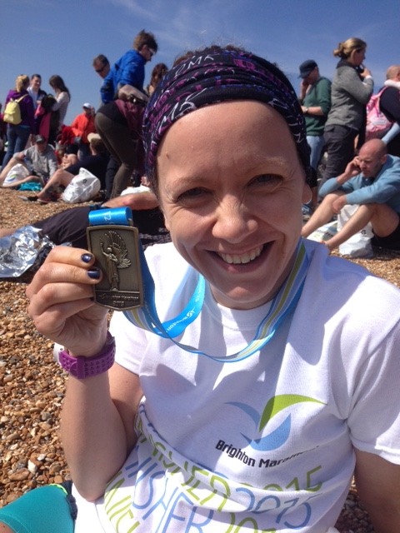

In the news

West Hull Ladies got a special mention in the Peter Pan Park run write up from its second birthday run:

"Despite the weather, we hope you enjoyed our park and look forward to welcoming you back again soon. Still the PB’s are coming with 12 of today’s runners managing to run our course quicker than they have previously. 4 of these were from West Hull Ladies, showing that this club is ready for the summer season, and their winter training with their club is paying dividends. For the ladies, this club provides a lot of support for their runners and plenty of racing opportunities with ladies of all abilities. If you are serious about improving your running, I can’t stress too highly the advantages of joining a club, and so much better than running on your own each time."

I completely agree!
Anna
2015 RACE DIARY
http://westhullladies.org.uk/races.htm

Free 5K time trial every Saturday 9am: Hull parkrun or Peter Pan parkrun Humber Bridge parkrun

Fancy something different? For worldwide marathons click here
 | Date/Time | Event | Fee | Entry forms | Online entry
April 2015
 | 3rd/10:00 | Bridlington Easter 5 Mile Dash | £13 UKA/£15 | Entry form | online entry (+£1.70)
 | 26th/10:00 | Virgin Money London Marathon | Race Full | Race Full | Race Full
May 2015
 | 3rd/09:00 | North Lincolnshire Half Marathon | £25 UKA/£27 | Online entries only | online entry
 | 10th/11:15 | Beverley 10K | Race Full | Race Full | Race Full
 | 10th/09:30 | Jane Tomlinson Leeds Half Marathon | £29.70 UKA/£31.70 | Online entries only | online entry
Please remember to double check dates, times and entry fees with the official website or the entry form.

Keep checking the website for new races and updates:

NOTE: Club Vests must be worn at any races you enter
under the West Hull Ladies running club name.

West Hull Ladies Road Running Club
Kit Order Form

FORENAME ___________________________________

SURNAME ___________________________________

ORDER - tick what you require and circle your size Price
- VEST SIZE 10 12 14 16 £16.00
- LONG SLEEVED SIZE 10 12 14 16 £18.50
- HOODIE SIZE XS S M L £20
- HOODIE with ZIP SIZE XS S M L £20
Note on size, M is approximately size 14
- BEANIE HAT £6.50
- PINLESS WHL NUMBER FASTENERS (set of 4) £3.00

DATE Ordered _______________

AMOUNT PAID _______________

Please transfer payments online with your name and marked as ‘Kit to:
Account: 63762742 Sort Code: 20 43 49

Or cheque payable to ‘West Hull Ladies RRC’, and write your name and ‘Kit’ on the back and give to Club Treasurer Linda Dodsworth, 110 The Stray, South Cave, E Yorkshire. HU15 2AL

Sign on receipt of goods _________________________________
DATE _______________

Please complete this form and email to diazmaria@btinternet.com
Thanks.
Maria Kit Officer

